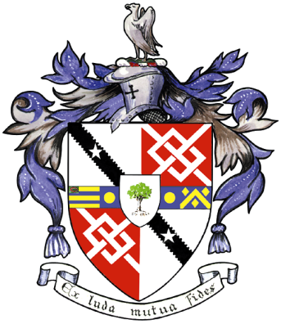
Davyhulme Park Golf Club

Gleneagles Road
Davyhulme
MANCHESTER
M41 8SA
Tel. 0161 748 2260
www.davyhulmeparkgolfclub.co.uk

SENIOR MENS OPEN - THURSDAY 8th June 2017
Four Ball Better Ball Stableford Competition

RESULT

Congratulations to winners of Pro shop vouchers to the value stated

Winners – Mr C. Fairhurst & Mr C Heyland with 47 points - £100.00 each – Vicars Cross G.C.

2nd prize – Mr S Wilson & Mr J Wheeler with 45 points cpo - £80.00 each – Heaton Moor G.C.

3rd Prize – Mr R Pomfret & Mr M Diggins with 45 points cpo - £60.00 each – Greenmount G.C.

4th Prize – Mr S Wilkinson & Mr I Chester with 44 points - £40.00 each – Rossendale G.C.

5th Prize– Mr N Gee & Mr D Mellor 43 points cpo - £20.00 each – Dean Wood G.C.

ADDITIONALLY
the winners of the draw for a free 2ball entry to any 2018 Seniors Open are:
Mr D Tracey & Mr Cheong of Greenmount G.C.
&
Mr J Sharpe & Mr B Weston of Haydock Park G.C.

Thank you for your support and hope to see you again at:
2017 Opens - 20th July, 7th September & 4th December
&
2018 Opens - 7th June, 19th July, 6th September & 3th December

Thank you for entering, Mike Goman, Seniors Secretary
Tel. 0161 747 4070 email: gomanmj@gmail.com
or gm@davyhulmeparkgolfclub.co.uk

