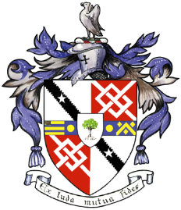
Davyhulme Park Golf Club

Gleneagles Road
Davyhulme
MANCHESTER
M41 8SA
Tel. 0161 748 2260
www.davyhulmeparkgolfclub.co.uk

SENIOR MENS OPEN TURKEY TROT
Four Ball Better Ball Stableford Competition
(90% handicap)

MONDAY 2nd DECEMBER 2019
1st, 2nd, 3rd Prizes (Turkey Crowns, Chickens & Wine)

Age Limit 55 and over on day of Competition
Entrance Fee £22.00 per couple including 2’s

ACTIVE HANDICAP IS COMPULSORY

NAME | CLUB | SHOTGUN  11 am | Phone  Number

Contact Name & Address: _______________________________________________
___________________________________________________________________
email: ____________________________________________________

Home Club: ________________________________________________

PREFERABLY BOOK ON LINE https://www.brsgolf.com/davyhulme/opens_home.php
Return the entry form to: Davyhulme Park Golf Club c/o Mike Goman accompanied by entry fee (and S.A.E. if hard copy receipt required)
Cheques should be made payable to Davyhulme Park Golf Club Ltd
Cheque No________________ Date__________ CDH No ___________________

Bookings are subject to the Terms and Conditions displayed on DPGC Open Competitions - Online Reservation webpage.
Handicaps certificates or CDH details will be required for all winners.
Prizes to be presented on the day.

Thank you for entering, Mike Goman, Seniors Secretary
Tel. 07590 778773 email: gomanmj@gmail.com

