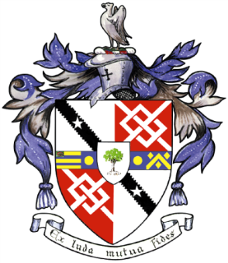
Davyhulme Park Golf Club

Gleneagles Road
Davyhulme
MANCHESTER
M41 8SA
Tel. 0161 748 2260
www.davyhulmeparkgolfclub.co.uk

SENIOR MENS OPEN - THURSDAY 15th July 2021
Four Man Team AM-AM Stableford Competition

RESULT

Congratulations to winners of Pro shop vouchers to the value stated

Winners – with 87 points cpo - £90.00 each
F Turner & E Walker Greenmount GC, D Beaumont Pike Fold GC, P Beaumont Rossendale GC

2nd Prize – with 87 points cpo - £60.00 each
R Taylor, R Allen, N Wood of Turton GC, J Major of Huddersfield GC

3rd Prize – with 86 points - £30.00 each
T Cook, P Rudkin, J Drabble, D Thompson of Houldsworth GC

2’s – 8 winners well done

Thank you for your support and hope to see you again at:

2021 Opens – 26th August & 29th November
&
2022 Opens – 9th June, 14th July, 25th August & 28th November

Thank you for entering, Mike Goman, Seniors Secretary
Tel: 07590 778773 email: gomanmj@gmail.com

