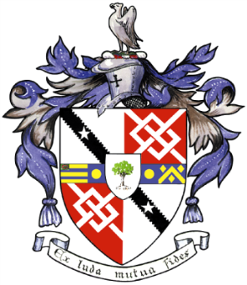
Davyhulme Park Golf Club

Gleneagles Road
Davyhulme
MANCHESTER
M41 8SA
Tel. 0161 748 2260
www.davyhulmeparkgolfclub.co.uk

SENIOR MENS OPEN - THURSDAY 26th August 2021
Four Ball Better Ball Stableford Competition

RESULT

Congratulations to winners of Pro shop vouchers to the value stated

Winners – Paul Bloomfield Heaton Park GC & Steve Pinnington Tytherington GC - 51pts - £90.00 each

2nd prize – Dave Higham Davyhulme Park GC & Dave Wright Worsley GC - 47 pts - £70.00 each

3rd Prize – Ken Clarke & Leslie Russon Bramhall GC - 45 pts cpo - £50.00 each

4th Prize – Nigel Barrow Silverdale GC & Simon Shimwell Carus Green GC - 45 pts cpo - £30.00 each

Plus 9 winners of “two’s”

Thank you for your support and hope to see you again at:

2021 Opens – 29th November
&
2022 Opens – 9th June, 14th July, 25th August & 28th November

Thank you for entering, Mike Goman, Seniors Secretary
Tel. 07590 778773 email: gomanmj@gmail.com

