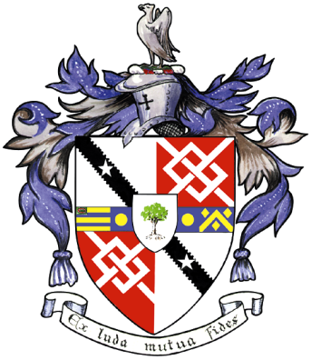
Davyhulme Park Golf Club

Gleneagles Road
Davyhulme
MANCHESTER
M41 8SA
Tel. 0161 748 2260
www.davyhulmeparkgolfclub.co.uk

SENIOR MENS OPEN - THURSDAY 20th July 2017
Four Man Team AM-AM Stableford Competition

RESULT

Congratulations to winners of Pro shop vouchers to the value stated

Winners – with 91 points - £90.00 each
Mr T. McNicholls, Mr G Boardman, Mr J Boardman & Mr B Freeman of Altrincham GC

2nd Prize – with 84 points cpo- £70.00 each
Mr R Ball, Mr D Latham, Mr J Kenyon & Mr P Preston of Lancaster GC

3rd Prize – with 84 points cpo- £40.00 each
Mr M Hughes Helsby GC
Mr M Clarkson Lymm GC
Mr P Jenkinson & Mr R Lewis Woolton GC

Other good scores:
84 points cpo - Mr J White, Mr J Taylor, Mr B Moss & Mr B Green of Hindley Hall GC

83 points - Mr R Bamber, Mr S Mawson, Mr G Nicholls & Mr D McGhee of Leyland GC

83 points - Mr P Dunn, Mr A Simpson, Mr D Harrison & Mr B Jones of Hindley Hall GC

ADDITIONALLY the OPEN day 1 leader at Birkdale on a card play-off was Brooks Koepka.
The draw winner of a free 4ball (or 2x 2balls) entry to any 2018 Seniors Open is:
Mr J Whelan of Astbury G.C.

Thank you for your support and hope to see you again at:
2017 Opens - 7th September & 4th December
&
2018 Opens - 7th June, 19th July, 6th September & 3th December

Thank you for entering, Mike Goman, Seniors Secretary
Tel. 0161 747 4070 email: gomanmj@gmail.com
or gm@davyhulmeparkgolfclub.co.uk

