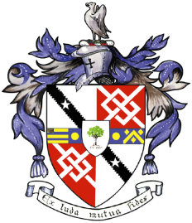
Davyhulme Park Golf Club

Gleneagles Road
Davyhulme
MANCHESTER
M41 8SA
Tel. 0161 748 2260
www.davyhulmeparkgolfclub.co.uk

SENIOR MENS OPEN TURKEY TROT
Four Ball Better Ball Stableford Competition
(90% handicap off White Tees)

MONDAY 7th DECEMBER 2017
1st, 2nd, 3rd Prizes (Turkey Crowns, Chickens & Wine)

Age Limit 55 and over on day of Competition
Entrance Fee £20.00 per couple including 2’s

ACTIVE HANDICAP IS COMPULSORY
NAME | CLUB | SHOTGUN  11 am | Phone  Number

Contact Name & Address: _______________________________________________
___________________________________________________________________
email: ____________________________________________________

Home Club: ________________________________________________
Return the entry form to: Davyhulme Park Golf Club c/o General Manager accompanied by entry fee and S.A.E.
Cheques should be made payable to Davyhulme Park Golf Club Ltd
Cheque No________________ Date__________ CDH No ___________________

Bookings are subject to the Terms and Conditions displayed on DPGC Open Competitions - Online Reservation webpage.
NOTE: DPGC competitors cannot sign up until one month before competition date and will have 1 point per DPGC player deducted from final points score
Handicaps certificates or CDH details will be required for all winners. Prize Vouchers will be mailed to winners.

Thank you for entering, Mike Goman, Seniors Secretary
Tel. 07590 778773 email: gomanmj@gmail.com
or gm@davyhulmeparkgolfclub.co.uk

