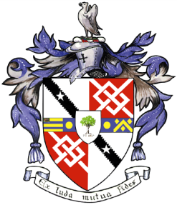
Davyhulme Park Golf Club

Gleneagles Road
Davyhulme
MANCHESTER
M41 8SA
Tel. 0161 748 2260
www.davyhulmeparkgolfclub.co.uk

SENIOR MENS OPEN - THURSDAY 6th September 2018
Four Ball Better Ball Stableford Competition

RESULT

Congratulations to winners of Pro shop vouchers to the value stated

Winners – Mr M. Hughes (Helsby GC) & Mr M Clarkson (Lymm GC) with 46 points - £90.00 each

2nd prize – Mr T James (Warrington GC) & Mr E Buckley (Walton Hall GC) with 44 points - £70.00 each

3rd Prize – Mr R Dumbill & Mr J Darbyshire - Warrington GC with 43 points – £50.00 each

4th Prize – Mr R Gaze & Mr D Trotter – Leyland GC with 42 points cpo - £30.00 each

Note there were 7 other pairs with 42 points

Thank you for your support and hope to see you again at:

2018 Opens – Turkey Trot 3th December

&

2019 Opens

6th June 4BBB
18th July team Am-Am
29th August 4BBB
2th December Turkey Trot

Thank you for entering, Mike Goman, Seniors Secretary
Tel. 07590 778773 email: gomanmj@gmail.com

