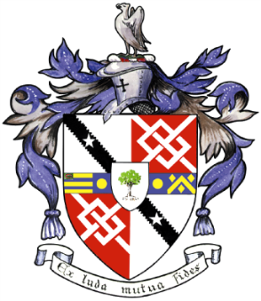
Davyhulme Park Golf Club

Gleneagles Road
Davyhulme
MANCHESTER
M41 8SA
Tel. 0161 748 2260
www.davyhulmeparkgolfclub.co.uk

SENIOR MENS OPEN - THURSDAY 19th July 2018
Four Man Team AM-AM Stableford Competition

RESULT

Congratulations to winners of Pro shop vouchers to the value stated

Winners – with 87 points cpo - £90.00 each
D Beech, E Galvin, J Mather of Gathurst GC, I Liptrot of Wigan GC

2nd Prize – with 87 points cpo- £70.00 each
B Green, J White, B Moss & J Taylor of Hindley Hall GC

3rd Prize – with 85 points cpo- £40.00 each
K Wilson, H Rusling, W Cornall & K Eccles of Ashton & Lea GC

Other good scores:
85 points cpo – R Ball, D Latham, J Kenyon & P Preston of Lancaster GC

85 points cpo - P Dunn, A Simpson, D Harrison & B Jones of Greenmount GC

Thank you for your support and hope to see you again at:

2018 Opens - 6th September & 3th December
&
2019 Opens - 6th June, 18th July, 29th August & 2th December

Thank you for entering, Mike Goman, Seniors Secretary
Tel. 0161 747 4070 email: gomanmj@gmail.com
or gm@davyhulmeparkgolfclub.co.uk

