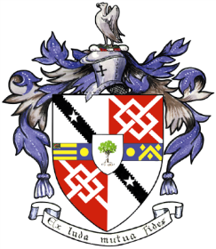
Davyhulme Park Golf Club

Gleneagles Road
Davyhulme
MANCHESTER
M41 8SA
Tel. 0161 748 2260
www.davyhulmeparkgolfclub.co.uk

SENIOR MENS OPEN
Four Ball Better Ball Stableford Competition
(90% handicap off White Tees)

THURSDAY 7th June 2018
1st, 2nd, 3rd 4th 5th Prizes
Age Limit 55 and over on day of Competition
Entrance Fee £30 per Couple including 2’s

ACTIVE HANDICAP IS COMPULSORY
NAME | CLUB | Preferred Tee Time | Phone  Number

Contact Name & Address: _______________________________________________
___________________________________________________________________
email: ____________________________________________________

Home Club: ________________________________________________
Return the entry form to: Davyhulme Park Golf Club c/o General Manager accompanied by entry fee and S.A.E.
Cheques should be made payable to Davyhulme Park Golf Club Ltd
Cheque No________________ Date__________ CDH No ___________________

Bookings are subject to the Terms and Conditions displayed on DPGC Open Competitions - Online Reservation webpage.
NOTE: DPGC competitors cannot sign up until one month before competition date and must reduce their handicaps by 2 strokes.
Handicaps certificates or CDH details will be required for all winners. Prize Vouchers will be mailed to winners.

Thank you for entering, Mike Goman, Seniors Secretary
Tel. 07590 778773 email: gomanmj@gmail.com
or gm@davyhulmeparkgolfclub.co.uk

