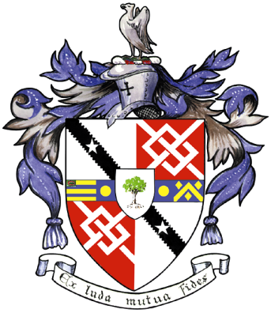
Davyhulme Park Golf Club

Gleneagles Road
Davyhulme
MANCHESTER
M41 8SA
Tel. 0161 748 2260
www.davyhulmeparkgolfclub.co.uk

SENIOR MENS OPEN - THURSDAY 7th June 2018
Four Ball Better Ball Stableford Competition

VOUCHER PRIZES
Gentlemen,

congratulations on winning a prize at our Seniors Spring Open.

Please find enclosed Pro shop vouchers to the value stated, also note that our Pro shop not only stocks golf equipment, but they have a catalogue containing none golf ‘stuff’, which I encourage you to peruse.

Winners – Mr S. Wilkinson & Mr R. Wilkinson with 50 points - £100.00 each – Rossendale G.C.

2nd prize – Mr M Maynell & Mr J Stoddart with 49 points - £80.00 each – Vicars Cross G.C.

3rd Prize – Mr M Lundquist & Mr P Davies with 47 points - £60.00 each – Abergele G.C.

4th Prize – Mr W Pearce & Mr R Wilson with 46 points - £40.00 each – Blundell Hill G.C.

5th Prize– Mr C Cheong & Mr F Turner 45 points cpo - £20.00 each – Greenmount G.C.

Thank you for your support and hope to see you again at:

2018 Opens - 19th July, 6th September & 3th December
&
2019 Opens - 6th June, 18th July, 29th August & 2th December

Yours sincerely

Mike Goman
Seniors Secretary, DPGC

Thank you for entering, Mike Goman, Seniors Secretary
Tel. 07590 778773 email: gomanmj@gmail.com
or gm@davyhulmeparkgolfclub.co.uk

