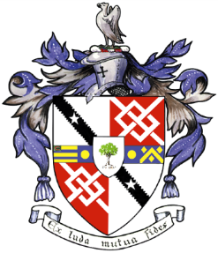
Davyhulme Park Golf Club

Gleneagles Road
Davyhulme
MANCHESTER
M41 8SA
Tel. 0161 748 2260
www.davyhulmeparkgolfclub.co.uk

SENIOR MENS OPEN TURKEY TROT- Monday 3rd December 2018
Four Ball Better Ball Stableford Competition

RESULT

Congratulations to:

Winners – £30 turkey crown voucher & wine each
Mr P Townley (Rossendale GC) & Mr S Bramwell (Bentham GC) with 43 pts.

2nd prize - £15 chicken crown voucher & wine each
Mr B Whelan & Mr F Nelson (Worsley GC) with 42 pts.

3rd Prize – wine
Mr S Lamont (Birchwood GC) & Mr G Harwood (Ellesmere GC) with 41 pts.

Note there were 4 other pairs with 40 pts.

2’s: Mr K Gibbons
Mr J Dobson
Mr N Namian
Mr C Icely

Thank you for your support and hope to see you again at:

2019 Opens: 6th June 4BBB
18th July team Am-Am
29th August 4BBB
2th December Turkey Trot

Thank you for entering, Mike Goman, Seniors Secretary
Tel. 07590 778773 email: gomanmj@gmail.com

