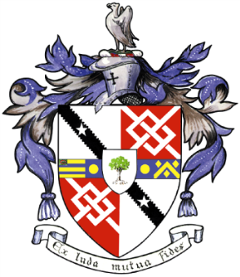
Davyhulme Park Golf Club

Gleneagles Road
Davyhulme
MANCHESTER
M41 8SA
Tel. 0161 748 2260
www.davyhulmeparkgolfclub.co.uk

SENIOR MENS OPEN - THURSDAY 16th July 2020
Four Man Team AM-AM Stableford Competition

RESULT

Congratulations to winners of Pro shop vouchers to the value stated

Winners – with 89 points - £90.00 each
T Dagnall, K Hulme, D Southern & G Unsworth of Withington GC

2nd Prize – with 86 points cpo - £60.00 each
K Davison, S Hamer, M Cominskey & A Wimbledon of North M/C GC

3rd Prize – with 86 points cpo - £30.00 each
C Vines, R Mason, J Hacking & J Crowther of Clitheroe GC

Other good score:
86 points cpo – S Bourne, P Pearson, W Potter & D Affleck of Harwood GC

2’s – 15 winners well done

Thank you for your support and hope to see you again at:

2020 Opens – 27th August & 30th November
&
2021 Opens – 3rd June, 15th July, 26th August & 29th November

Thank you for entering, Mike Goman, Seniors Secretary
Tel: 07590 778773 email: gomanmj@gmail.com

